Unlock Account


If you have attempted multiple times to login at digitalcookie.girlscouts.org and did not successfully input your password, you may find yourself locked yourself out. You can contact Customer Support or Unlock your account.

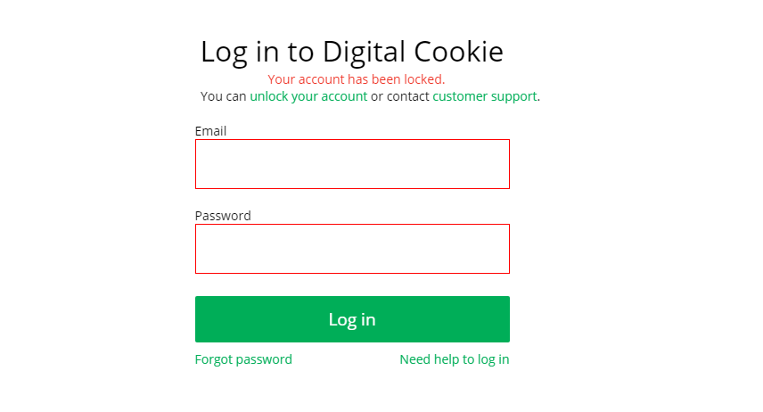

If you click the “Unlock Your Account” link, you will be asked to validate the email address you use for Digital Cookie, then click the “Send Email” button
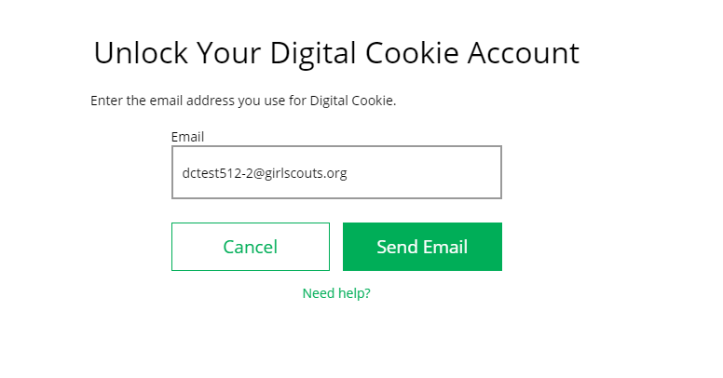

You will be sent an email with the subject: “Your Pin Code” from “Girl Scout Cookies” (email@email.girlscouts.org). Check your junk/spam/promotions if you don’t receive it and be sure to add email@email.girlscouts.org to your “safe sender” list.
You will have a Pin Code in the email.

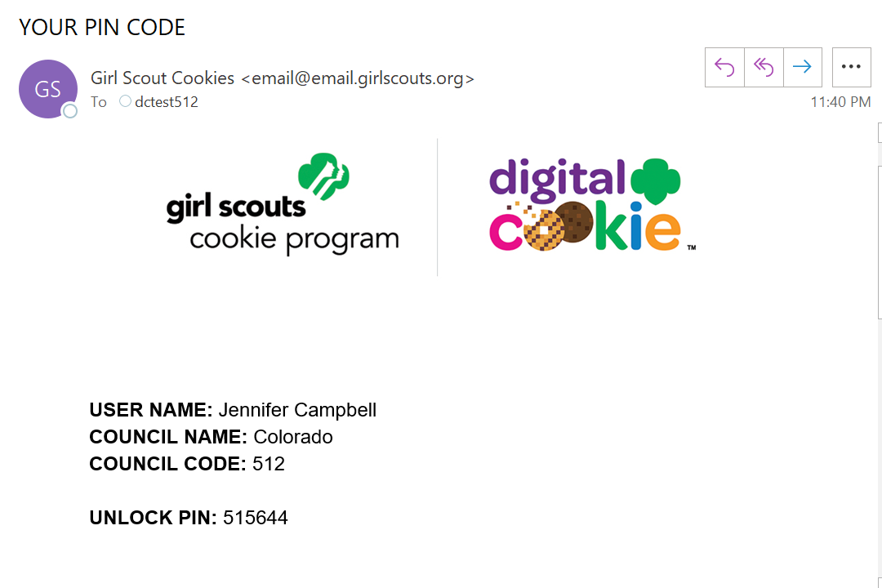

Enter that Pin Code back in Digital Cookie on the unlock screen, then click on “Verify”.
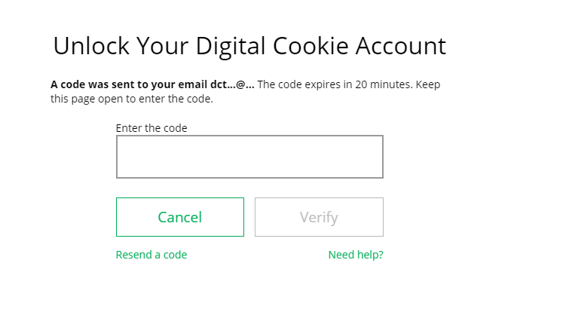


You will be taken back to the Digital Cookie login screen with your account unlocked and ready for you to attempt to login again. If you are unsuccessful logging in, consider resetting your password using the “Forgot Password” link.
Otherwise, login and get started with your Digital Cookie experience.

